Unit 2: Lesson 11
It’s in Every One of Us

Goal: To learn that the intellectual positive action of creating helps us feel good about ourselves.

What makes a preschooler jump out of bed, run outside in his pajamas, and start building highways in the sandbox? What makes parents stay up way past midnight building a playhouse for their children? What makes the family cook pore over cookbooks, combine three recipes in a whole new way, and add special touches to make a beautiful meal for Grandma and Grandpa? What is the spark, the gusto, the enthusiasm that makes our lives fun?
What is it? It’s creating! And we all do it all the time!
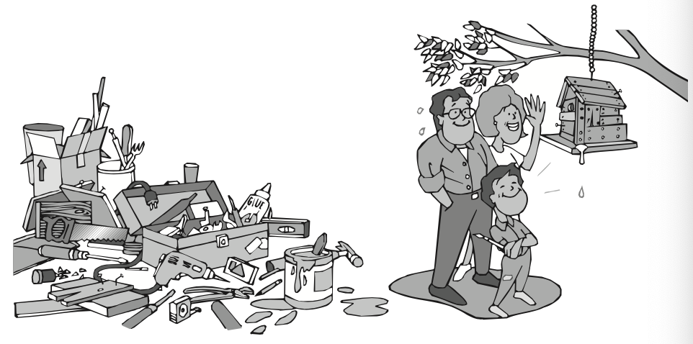

Creating is the most important positive action that we can do. Creating is the most positive action we can take to feel good about ourselves. We feel good when we see something we have made or accomplished.
Creating is a natural part of being human. We are creating when we put something together or cause certain things to happen that are new to us. Although we create things we can touch, eat, see, or do, we also create new thoughts, new ideas, and new attitudes, particularly for ourselves. Creating isn’t just limited to writers, artists, architects, or scientists. It’s in the way we live our everyday lives. Human beings are blessed with a wealth of creative ability.
Creating is a way of expressing ourselves. Everything we make or do represents our thoughts, feelings, and abilities in one way or another. But we all have unique abilities to create in a few special areas of our lives, to express ourselves in ways that are unique to us, that are ours alone.
For instance, maybe we like machines, the roar of engines, and large crowds screaming encouragement. The place we are most productive is at the speedway, creating and testing, working and reworking on the fastest car we can build. If that’s the case, we will never be happy sitting at a computer in a quiet room. We do better, work harder, and create more joyfully in the areas of our lives we like best. The closer we get to creating the life we really want, the better we will feel about who we are, what we are doing, and how we treat others.
Our jobs offer us the opportunity to create. We might create leadership, organization, or ways to meet the needs of other people. We might be creating an environment in which children can learn or a lively and stimulating workplace where employees are productive and satisfied with the work they do. Whatever we work at, we feel better about what we are doing with our lives if we think we are creating and contributing something important to ourselves, our families, our employers, and our communities. We feel as if we’ve accomplished something significant and created something of value.
A plumber faced with replumbing an old house has to think how to lay out the pipe. That plumber is creating. A nurse caring for a child with two broken arms has to create ways to help the child eat or blow his nose. And a student thinking about the next step in a science project is creating, too.
And what about the police officer who patrols the streets to create a feeling of safety and sanity? What about the judge who creates a sense of justice and fairness in the courtroom? Or the social worker who creates hope and stability for a family struggling to overcome serious problems? What ever it is, our whole life and the lives of those around us are enhanced by our responsible choice to create in positive ways.
Creating is art in action. When we paint pictures that are beautiful or inspiring, we leave something important behind us, something that moves other people to feel or think, When we write stories that help people think about themselves in a new way, we connect with other people through our feelings and our thoughts. Welding, gardening, sewing, designing, and building are also ways we communicate and ways we create with our hands, our hearts, and our heads. Creating takes all of our physical, intellectual, social, and emotional skills and abilities. That’s why is makes us feel so good about ourselves. The thrill and satisfaction we get from making something new enhances our self-concept like nothing else can.
It’s important that we be consciously aware of how good it feels to create. When we need to give our self-concept a boost, we can create. Creating is the most positive of the positive actions. We feel the very best about who we are and what we are doing when we are creating. So, let’s roll up our sleeves, gear up our minds, and create!

QUESTIONS:
- What is creating?
- Why is creating an important positive action?
- What things can we create?
- How can we discover what we create best?
- How does creating affect self-concept?
- What do you enjoy creating?
- What would you like to create in your life?
- How do you feel about yourself when you create something that contributes to others?
- How could creating affect your success and happiness?
Spend some time thinking about what you’d like to create in your life. Maybe you’d like to create more friends or better relationships with the ones you already have. Maybe you’d like to create a better attitude toward your school or your job. Maybe you’d like to create something artistic, such as a song, a poem, a photograph, or a painting.
Think of several ways to create or bring about what your want. Jot your steps down. Get started as soon as possible.

FAMILY POSITIVE ACTIONS
QUESTIONS:
- How does creating affect us as a family?
- What would we like to create as a family?
- In what ways are we willing to work together to create?
- How does our creating together affect one another?
- How could creating help our family become the best it can be?
As a family, let’s make a plan to practice the positive action of creating. Let’s determine how we can create a more positive atmosphere in our home. Maybe we could create a better attitude toward one another. Perhaps we should look at creating more patience, trust, or respect among ourselves. Let’s decide what we can do and agree to work together on it this week.
Let’s also think about creating something physical. We could create our own game, family picture album, or family video show. May be would rather plant a flower garden or create a new family recipe.
parent postive actions
Ask yourself: What do you enjoy creating as a parent? How could creating help you become a better parent? In what ways do you make parenting creative and fun? How can you help you children enjoy creating?
Plan and Do: Look for ways to make your role as a parent more fun and interesting. Practice creating a loving atmosphere in your home. Try creating special moments by doing little unexpected things that add fun to your lives.
Encourage your children to create. Give them opportunities to express their desires. Show your appreciation for their creativity that they contribute to the family.
COMMUNITY POSITIVE ACTIONS
Let’s think of a role we could play in creating a better community. Let’s create a new approach to a neighborhood or school issue.
We might want to invite our neighbors to our home or hold a neighborhood party to get their views on the issue. We could ask everyone to brainstorm together to find a creative solution to the issue and then take immediate action on the most acceptable solution. As a community, we could present our findings to the appropriate authorities (school board, township supervisors, borough council, etc.)

SUMMARY
We feel especially good about ourselves when we are creating. Creating is putting things together to form something that is new to us. Or it can be making new things happen. It’s within every one of us to create.
Creating is a way of expressing ourselves. Everything we make and do represents us in one way or another. We can create in a multitude of areas, but there are usually a few areas in which we like to create best. We work harder and create more joyfully in these areas. It’s important for each of us to find these areas. It’s important for each of us to find these areas and create in them as often as we can.
For some of us, our best creating may be through personal hobbies. Others of us find that we do our best creating while we are working at home or at our jobs. We may find that our best creating happens in relationships as we create friendliness, encouragement, fun, and other positive attitudes.
Being aware of the thrill and satisfaction creating provides is especially important when we are feeling low. Finding something to create picks us up by enhancing our self-concepts. We feel happiest and most successful when we are creating in the areas we like best.

Word of the Week: Curious
Eager to learn how and why things happen.

